Parameters of Wings for Flight Biology

Wing Loading
https://www.sciencelearn.org.nz/resources/301-wing-loading
“Wing loading is a measurement that relates the mass of an aircraft or bird to the total wing area. The relationship between wing area and body weight is given in kilograms per square metre (or grams per square centimetre).

To calculate wing loading, divide the mass of the bird or plane by the total area of the upper surface of its wings: wing loading = body mass (kg)/wing area (m2).

“The relationship between wing area and body weight is given in kilograms per square metre (or grams per square centimetre). To calculate wing loading, divide the mass of the bird or plane by the total area of the upper surface of its wings: wing loading = body mass (kg)/wing area (m2).”

DAVID N. BYRNE, STEPHEN L. BUCHMANN and HAYWARD G. SPANGLER (1988) Relationship between wing loading, wingbeat frequency and body mass in homopterous insects. J. Exp. Biol. 135, 9-23 (1988)
“Wing loadings for these insects were calculated in gcm~2 by dividing mass by total wing surface area. Total wing surface area was determined by summing twice the mean of the forewing area with twice the mean of the hindwing area.”

Aspect Ratio
Aspect ratios were calculated as the radius2/area of the wing=wing length squared divided by surface area

Wing length = distance from hinge point at body to farthest point of wing tip.

C. R. Betts and R. J. Wootton (1988) Wing shape and flight behaviour in butterflies (lepidoptera: papilionoidea and hesperioidea): a preliminary analysis. J. Exp. Biol. 138, 271-288 (1988

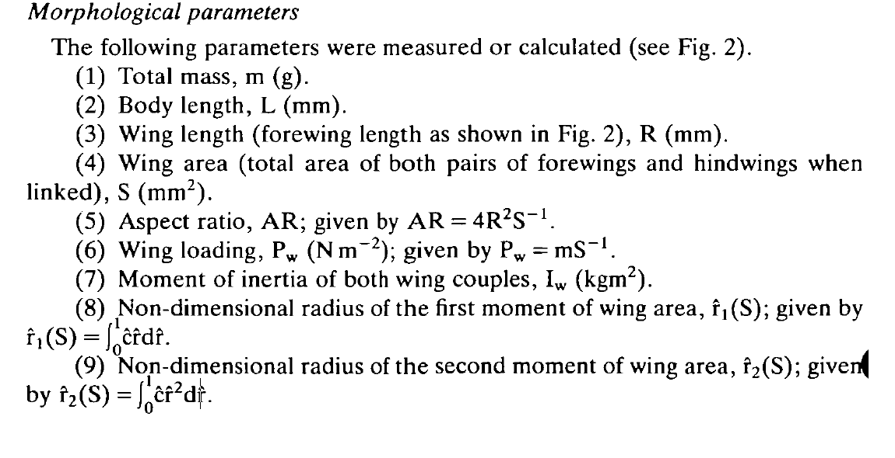

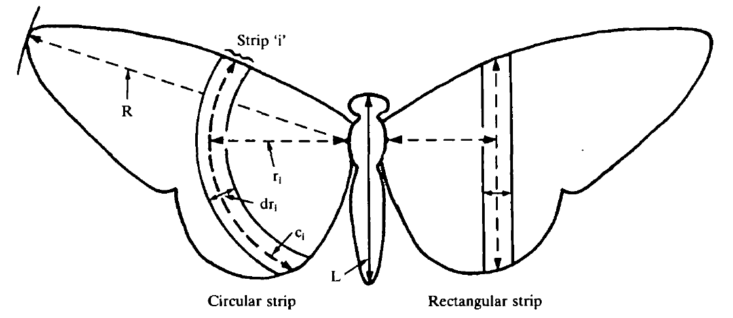

- - - - - - - - - - - - - - - - - - - - - - - - - - - - - - - - - - - - - - - - - - - - - - - - - - - - - - - - - - - - - - - - - - - - - - - - - -
Hassall (2015), Strong geographical variation in wing aspect ratio of a damselfly, Calopteryx maculata (Odonata: Zygoptera). PeerJ 3:e1219; DOI 10.7717/peerj.1219
“Aspect ratio was then calculated separately for both fore and hind wings as wingspan²/wing area.”
“It has been suggested that wing aspect ratio does not provide sufficient detail to
be morphologically informative in butterflies (Betts & Wootton, 1988) or dragonflies
(Johansson, S¨oderquist & Bokma, 2009).”

Phillips N, Knowles K, Bomphrey RJ. (2015) The effect of aspect ratio on the leading-edge vortex over an insect-like flapping wing. Bioinspir Biomim. 2015 Oct 9;10(5):056020. doi: 10.1088/1748-3190/10/5/056020.
“One of the most defining and aerodynamically significant measures of [insect] wing shape is the aspect ratio, defined as the ratio of wing length (R) to mean wing chord (c).”

Diana D. Chin and David Lentink (2016) Flapping wing aerodynamics: from insects to vertebrates. Journal of Experimental Biology (2016) 219, 920-932 doi:10.1242/jeb.042317
[Items from a glossary in the freview]

Fixed wing aspect ratio
The ratio of the wing length from tip to tip to average chord length,
calculated as wing length squared divided by surface area.

Flapping wing aspect ratio
The ratio of wing radius from the shoulder to the wingtip to average chord
length, calculated as wing radius squared divided by surface area.

